# **Growing, Growing, Gone!**

**Zoe's avatar**

[Zoe](https://substack.com/@zoeffc)

Aug 23, 2024

Share

Hi there!

It’s been a couple of months of the Cooperative and I think it might be good to come back to what this is all for.

I created the Femme Futures Cooperative because, throughout our education and in our media, we are told that we need to be leaders, take initiative, and make changes. A lot of us got good at that too, whether we were student leaders in high school, entrepreneurs whilst in college, or dutiful interns during our summers. And then we got to our first job — an entry-level role — and learned that it’s to our detriment to give 120%. You must remember that “children should be seen and not heard”.

Today, I want to talk about growth trajectories and about settling. Talk about a tough pill to swallow.

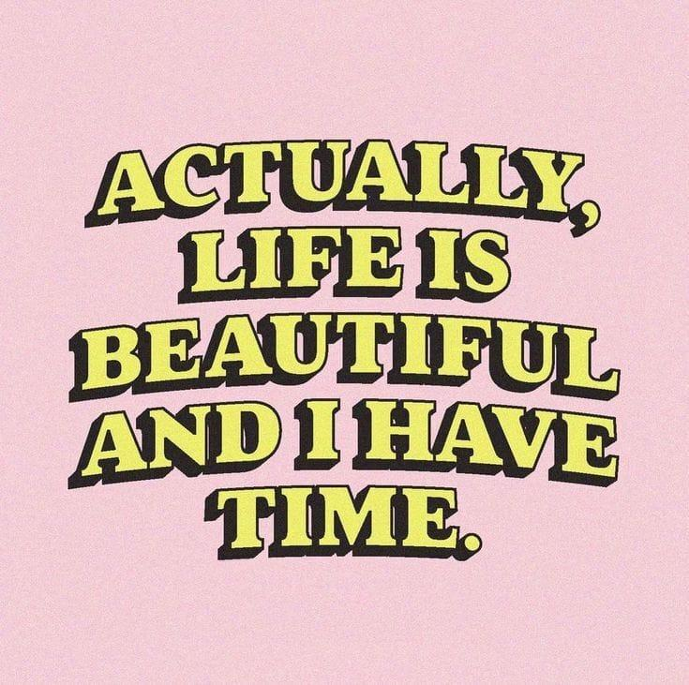

*artist unknown*

First some housekeeping:

📫 If a friend forwarded you this newsletter (then you have some really cool friends), and you may want to consider joining us [*here*](https://femme-futures.beehiiv.com/subscribe) for regular updates.

[Subscribe](https://femme-futures.beehiiv.com/subscribe)

🧲 Got some thoughts you want to share? Join us on [*Discord*](https://discord.gg/592wuyvx?utm_source=femme-futures.beehiiv.com&utm_medium=referral&utm_campaign=growing-growing-gone) to chat all things newsletter and corporate life.

[Discord](https://discord.gg/N84WxemQ?utm_source=femme-futures.beehiiv.com&utm_medium=referral&utm_campaign=growing-growing-gone)

You can find all archived newsletters at the online site, if you ever want to go back or if you just feel like perusing.

[Check out the website](https://femme-futures.beehiiv.com/)

This likely isn’t new news: growth is nonlinear.

Trust me, I also think that I can defy this law and be on a constant upwards trajectory and am truly confounded and disappointed when I inevitably plateau or even regress. I actually quit my first job because I was regressing (a story for another time).

Let’s step away from that voice in our head that says “I should be better by now” and think about a plant. Is it super exciting when your plant grows a new leaf? Absolutely. Do you expect the plant to continuously be producing new leaves? What about if the roots are expanding and you just can’t see it? OR what if the plant is adapting to new conditions? Or reenergizing? Has the plant failed?

Growth happens in plateaus — sometimes there is a lot all at once, and sometimes we feel like we are running in place. The bonus is that when we are in one phase, we wish we were in the other. I start a new job in a week and I know that I am going to be launched from my boring plateau to my scary growth.

I came to this week’s note craving growth and change. I just want to have all of *this* figured out already. That being said, I know that growth is hard too. Usually, when we grow, it’s because we are doing something new or different. We grow a lot more when the change is very big or very different, but that change comes with fear and stress. Not to stretch the metaphor, but growth comes with growing pains.

I feel like I spend a lot of time feeling like I’m not where I want to be yet. I’m not good enough at what I care about yet, I do not have access to the opportunities that I want access to yet, and I am not in a position that I want to be in yet. It’s frustrating. I know that it is good to remember that the only way to get those things is to go through these things; and that it’s about the journey, not the destination; and if you were already there, where would you have left to go. (I hope that in writing those out, I am reminding myself and you, even if they seem to fundamentally miss the point sometimes.)

Now, to talk about settling. We all do it at moments. It feels shameful, knowing that we want better but are accepting less. But right now, that less is what is going to get us to the better. It’s ok to lose sight of the dream or for it to morph and change. For instance, there has always been a part of me that has wanted to be a novelist. I went through years of actively working towards that goal, and years where that faded into the background. It’s more in the background for me now, but the desire to call myself a writer pushed me into my first job. The skills from that job are helping me show up for this passion project. This passion project is helping me get through a plateau without going crazy. Moral of the story: settling might be the just the thing to allow you to assess the course you’re on and then keep pushing.

I don’t want you to settle long-term. I think that the world will be a better place if you push to do the best that you can at what you care about. But I want you to know that settling, like plateaus and growing pains, is part of the process. They’re shitty, but present.

The Cooperative is meant to be a place where we get through these growth phases together. They suck and are hard and daunting, but also are exciting and the stuff of dreams.

I hope that as you read this today, you remembered that what you are doing is hard. It takes strength to grow through what you are experiencing every day. I hope that you keep striving for a world that you want to be a part of and keep dreaming.

I’m rooting you on!

Zoe

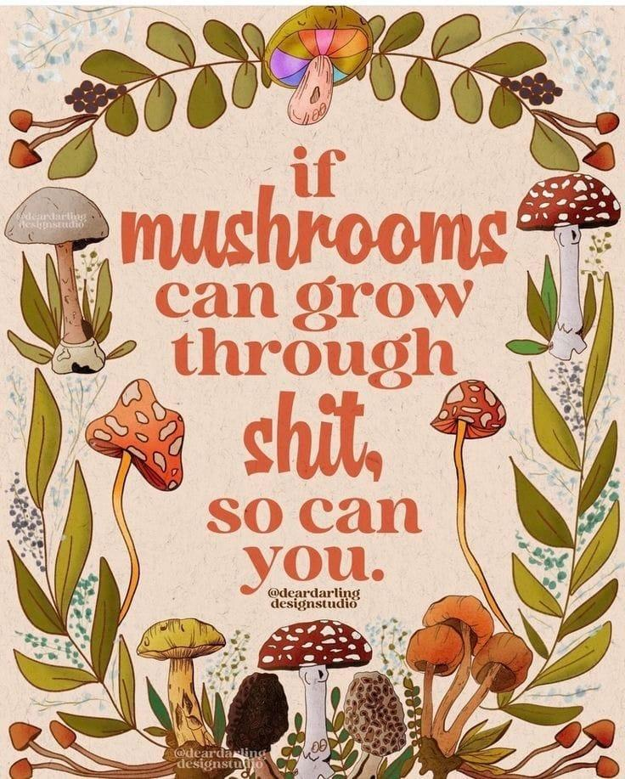

**Femme Futures Cooperative Founding Principles**

💚**Mission**: The mission of Femme Futures is to create a community space for young professionals who identify as over-achievers and activists to generate collective success by providing resources and platforms to thrive in challenging workplace environments.

💙**Vision**: To contribute to a world where driven individuals are equipped with the tools, guidance, and connections to overcome systemic barriers, fully utilize their talents, and enact positive change in their organizations and communities.